DIS-ME- Ur-Nammu (fl. ca. 2047-2030 BCE)

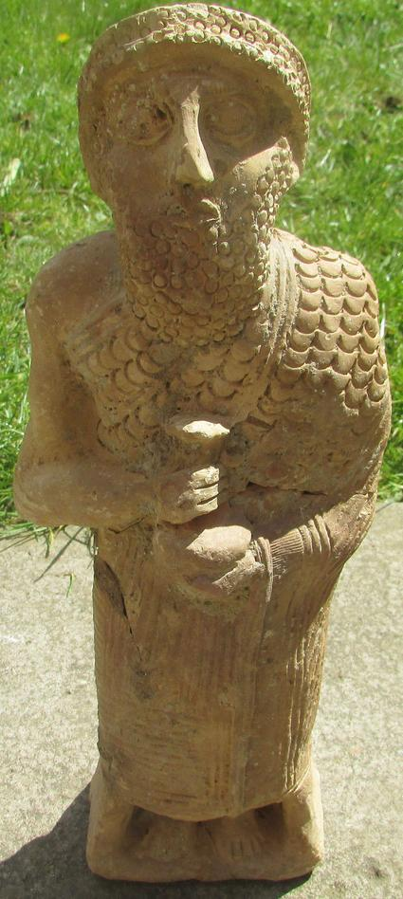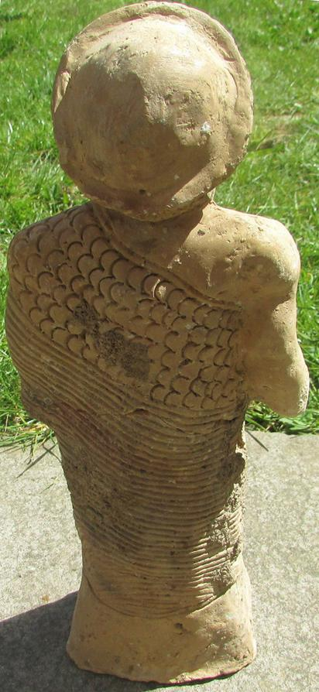

Fig. 1, a-b. Terracotta figure of Ur-Nammu (fl. ca. 2047-2030 BCE).

Formal Label: Ur-Nammu (fl. ca. 2047-2030 BCE), ceramic statue of founder of the Sumerian 3rd dynasty of Ur.

Accession Number:

**LC Classification:** DS69.5.A1

**Display Description:** Ur-Nammu (fl. ca. 2047-2030 BCE) was the founder of the Sumerian 3rd dynasty of Ur and compiler of the first legal code in history. In this ceramic statue he is holding a vase overflowing with water, "au vase jaillissant," in the manner of the preceding kings of Lagash, Gudea (ca. 2144 – 2124) and his son Ur-Ningirsu (ca. 2125–2100 BCE). The overflowing vase may refer to his concerns about clean water for his people, as he was well-known to have taken an active interest in the infrastructure of the cities under his control.

Date or Time Horizon: 2047-2030 BCE

Geographical Area: Ur, Sumeria, Southern Mesopotamia

**Map, GPS coordinates:** 30.962776°, 46.103188°

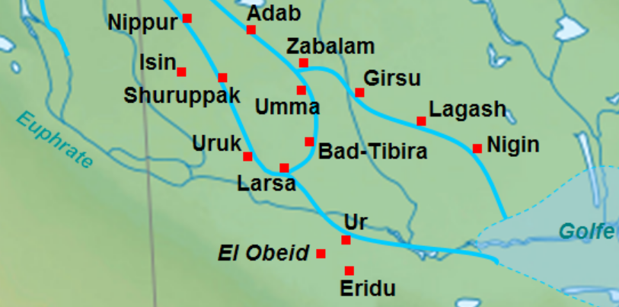

Fig. 2. Map of the location of Ur and other cities of Sumeria. After https://upload.wikimedia.org/wikipedia/commons/d/da/Basse_Mesopotamie_DA.PNG

Cultural Affiliation: Ur, Sumeria

Medium: fired clay.

Dimensions: Height 31.2 cm x Width 11.3 cm

Weight:

Condition: original. This figure has a repaired crack across the upper torso.

Provenance: Michael Davies, 2 Hanover Court, Didcot, Oxfordshire, ox11 8nu, United Kingdom.

**Description:**

This statue resonates with a particular irony, since one of the year-names of his reign records his devastation of Gutium, and its kings, whom he now tends to emulate as the bringer of fresh water and legal reforms: "Year in which Ur-Nammu the king put in order the ways (of the people in the country) from below to above", and "Year Ur-Nammu made justice in the land" (Ur-Nammu N.d.).

His military conquests of Lagash (the seat of Gudea and his son) and Uruk established him as a competent regional ruler. He also constructed buildings at Nippur, Larsa, Kish, Adab, and Umma and restored the infrastructure of the countryside and inter-city roads after the stagnant Gutian period (Hamblin 2006). He was also responsible for ordering the construction of a number of ziggurats, including the Great Ziggurat of Ur.

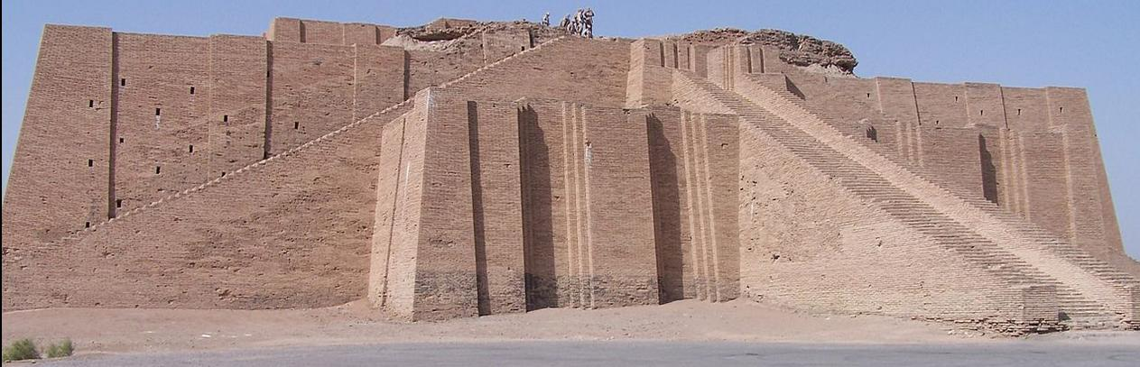. The Fig. 3. The Great Ziggurat at Ur in 2005 taken by an anonymous U. S. Serviceman. After https://upload.wikimedia.org/wikipedia/commons/thumb/9/93/Ancient_ziggurat_at_Ali_Air_Base_Iraq_2005.jpg/800px-Ancient_ziggurat_at_Ali_Air_Base_Iraq_2005.jpg

The Great Ziggurat at Ur which, in Sumerian *é*-*temen-ní-gùru* = “Etemenniguru” means the “temple whose foundation creates “fear” (Klein 1981: 162). It was located near Nasiriyah, in present-day Dhi Qar Province, Iraq. Sir Leonard Woolley reconstructed its original state (see Fig. 3) and believed a temple to Nanna**/**Sîn had been placed on its summit.

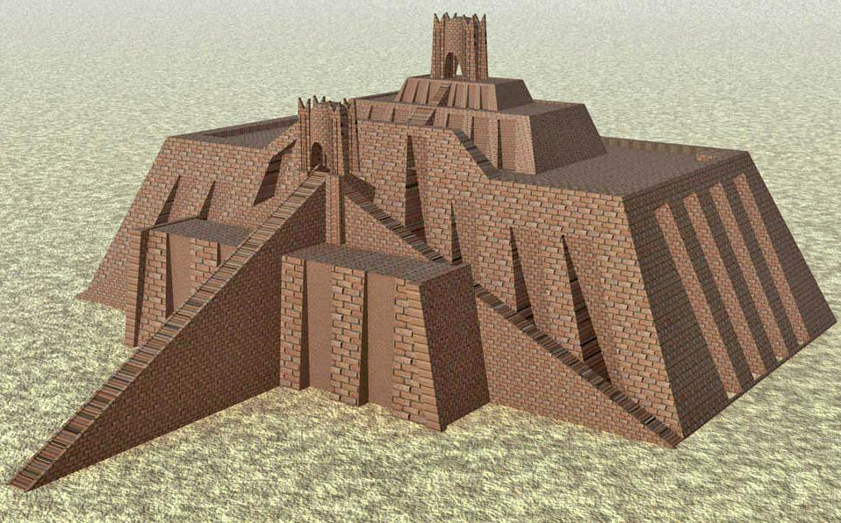

Fig. 4. The Great Ziggurat at Ur reconstructed with a temple to the Moon-god Nanna/Sîn at its summit. After Woolley 1939.

Based on an important cylinder seal, the stepped temples built by Ur-Nammu were dedicated to the Sumerian Moon-god, Nanna/Sîn.

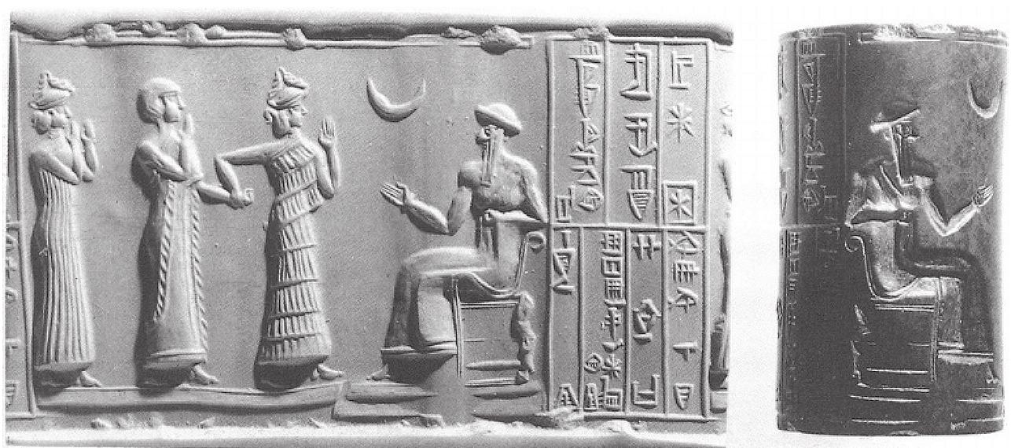

Fig. 5. Cylinder seal impression of Ur-Nammu (fl. ca. 2047-2030 BCE). Original: British Museum (WA.89126), Ref.: MacKenzie 1915: 50. Width - 9 cm / 3-1/2 inches; Height - 5.5 cm / 2-1/4 in.

In this cylinder seal (Fig. 4) Ur-Nammu greets a *lamassu* or protective goddess who is leading the owner of the seal, ašamer, on whom the *ensi* or pa.te.si, , a local governorship of Iškun-Sîn in southern Mesopotamia is being bestowed by Ur-Nammu who is seated to the right, thus marking the end of Gutian rule. The inscription on this cylinder seal impression reads – “Ur-Nammu, the mighty hero, king of Ur, ašamer the governor of Ishkun- Sîn his servant”.

Nanna had not always been identified with the Semitic moon god Sîn. It was only after the conquests by the founder of Akkad by Sargon (2334–2279 BCE) that the two had become syncretized. Nanna/ Sîn worship centers were located at Ur in the south of Mesopotamia and at Harran in the north.

Ur-Nammu, after an eighteen-year reign, died fighting on the battle-field against the Gutians, after his army had been routed. He was commemorated in a long Sumerian poetic composition extolling his accomplishments (Hamblin 2006). He was succeeded by his son Shulgi, (ca. 2029 BCE – 1982  BCE) who completed the Great Ziggurat of Ur his father had begun. It was probably at this time that the terracotta statute of him was produced, to commemorate his accomplishments and to stress his roles as the first lawmaker, a builder of stepped temples to Nanna**/**Sîn, and a ruler concerned about the water resources and infrastructure of his cities as they affected the welfare of his people.

References:

Hamblin, William J. 2006. *Warfare in the Ancient Near East to 1600 BC*. New York: Routledge.

Klein, Jacob. 1981. *Three Šulgi hymns: Sumerian royal hymns glorifying King Šulgi of Ur*, Bar-Ilan University Press.

Mackenzie, Donald A. .1915. *Myths of Babylonia and Assyria.* London: Messrs. Mansell & Co.

Ur-Nammu. N.d. [*Year-names for Ur-Nammu*](http://cdli.ucla.edu/tools/yearnames/HTML/T6K1.htm)*.*

Woolley, C. Leonard. 1939. The Ziggurat and its Surroundings. Ur Excavations. London ; Philadelphia : British museum: University Museum.Vol. 5.